In the realm of digital technology, the authorship is an active interplay between the designer and the user. The digital world is filled with training data and inputs curated by the designers, but how users choose to interact with these systems shapes the ultimate experience. The designed space leads the user, potentially manipulating their actions, yet users inevitably bring their own creativity into the process. This co-generation, where both users and designers learn from each other, enhances the tool's development, adapting it to better serve its audience.

User inputs are crucial for increasing engagement and stickiness. Regardless of the tool's intended purpose, users often redefine its use in ways the designer might not have imagined. In my practice, I embrace this user-centric approach, allowing users to take majority control over the tool. This approach reflects my stakeholder diagram, which considers diverse audiences with varying needs for flexibility and lock-in.

Jaron Lanier’s concept of “lock-in” in technology highlights the trade-offs between rigidity and adaptability. I believe certain aspects benefit from lock-in to ensure consistency and reliability in my work, particularly for new users. Key features should consider the short-cuts and affordability of the demography of my potential users. However, flexibility is central for those who seek more control and customization. This balance caters to different user journeys and enhances the overall user experience. I believe that the responsibility of authorship is shared between users, designers, and businesses. Control should be distributed to allow users to influence the system over customization, while designers maintain the ethical and foundational rules of the tools, and businesses uphold accountability for the technologies they deploy.

Open to user inputs vs Mission focus tools

Notion and Apple Notes

* Notion is a highly customizable platform that could serve various needs of users, whether it is a huge complex project vs smaller daily task. Whereas the apple notes give users the ease of jotting down texts and ideas for future reference. I think notion is a powerful tool but it leverages a high level of user efforts and inputs to learn and manipulate their “mind space”.

Google Maps vs Citymapper

* Google maps allows users to create customized mind maps all around the world. Gives us the ability to navigate adjacencies with the load of information. Versus citymapper is strictly designed to make commuting easier. It features a clean interface and strictly what is helpful for people on the go, from all the transit options to fast calculation to the fastest/easiest way to get to your destinations.
* 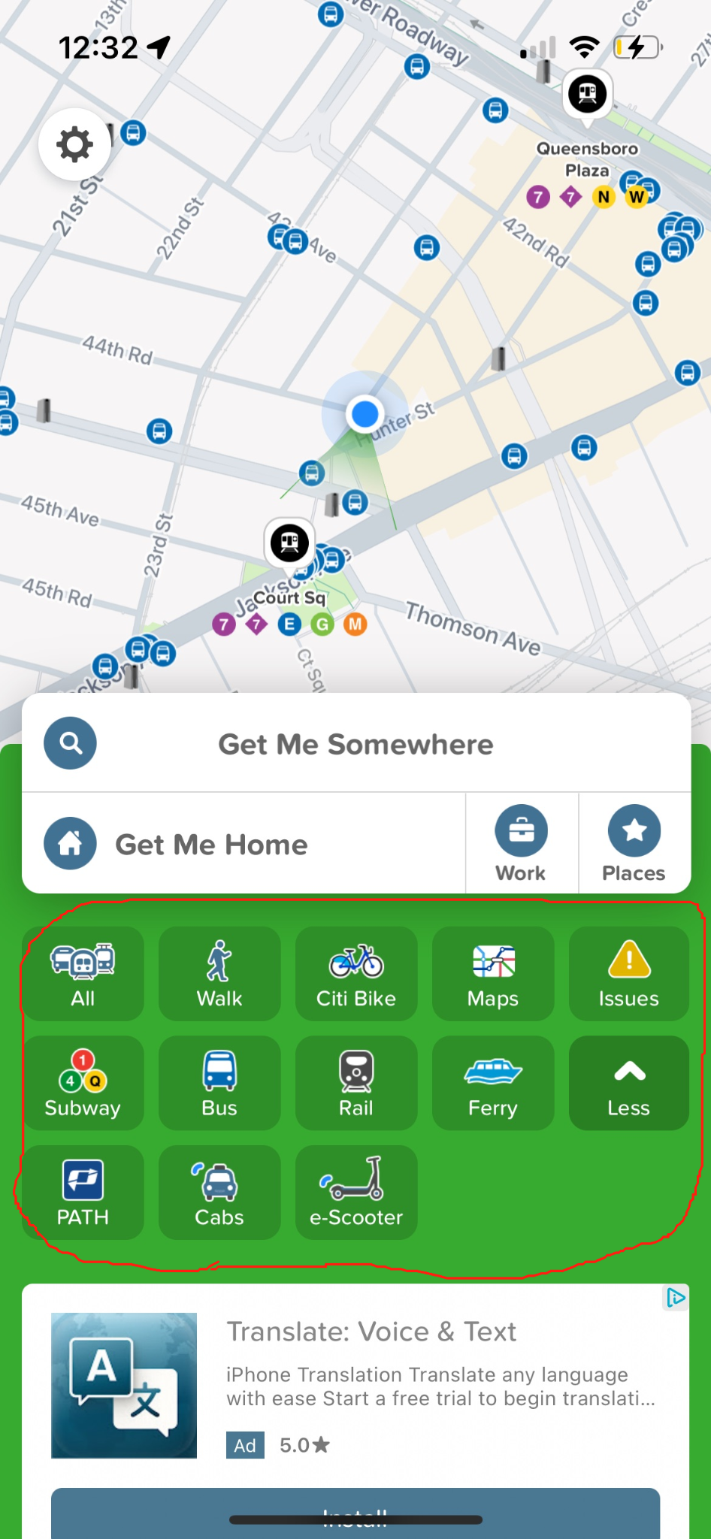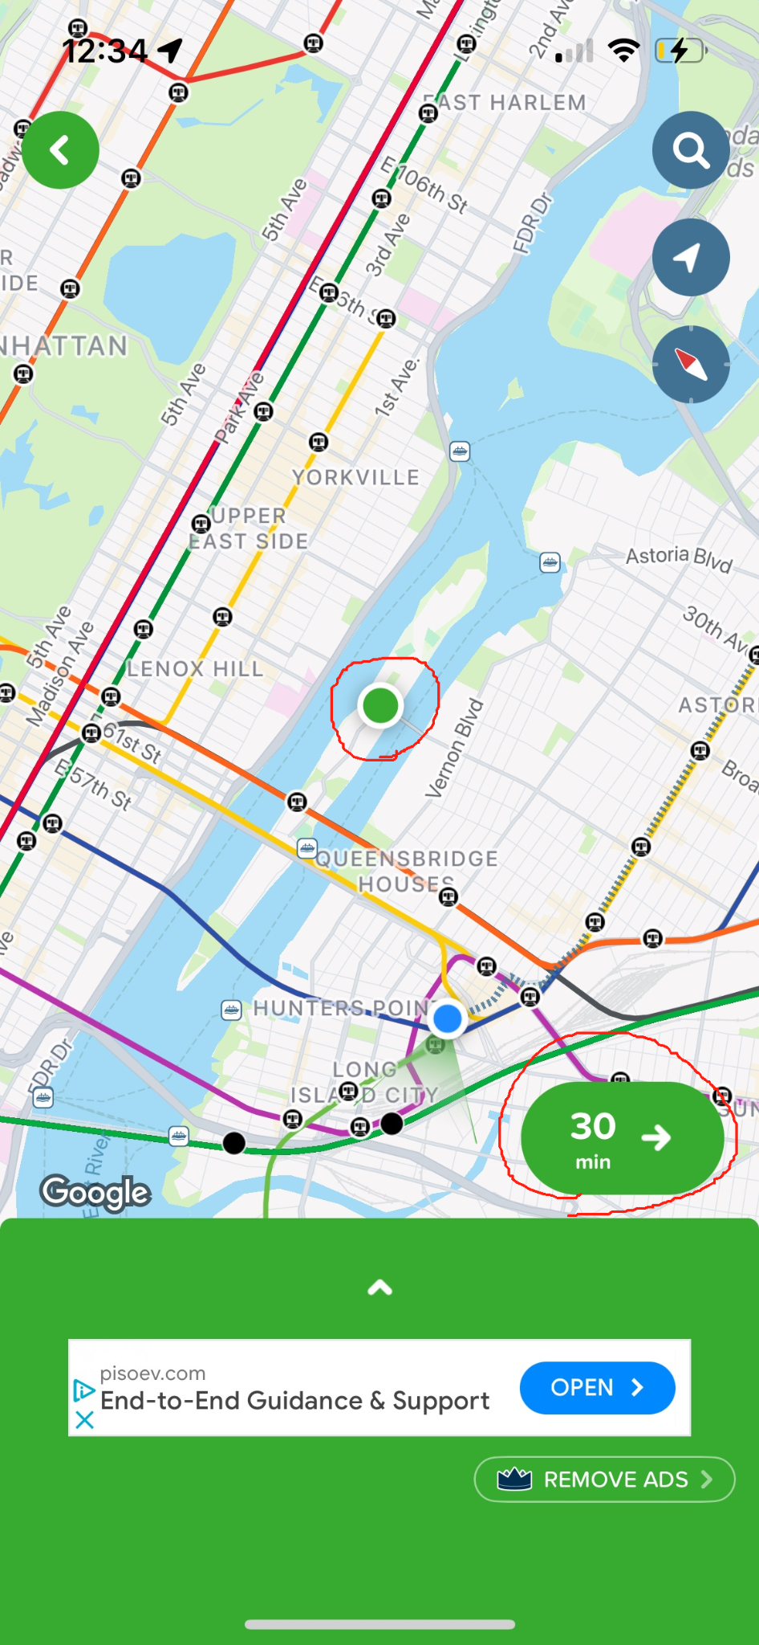

Realtor.com vs Zillow.com

* Realtor feature more information that could potentially affect the property value behind the scenes in addition to the buy/sell/rent transaction. The users are better informed about the property that they are investing in, such as flood maps, crime rates, etc. 